2025

Ricardo José Molina Gonzalez Reza Naidji Samuel Williams

ETS1603C Intro to Robotics

4/29/2025

Autonomous Vehicles

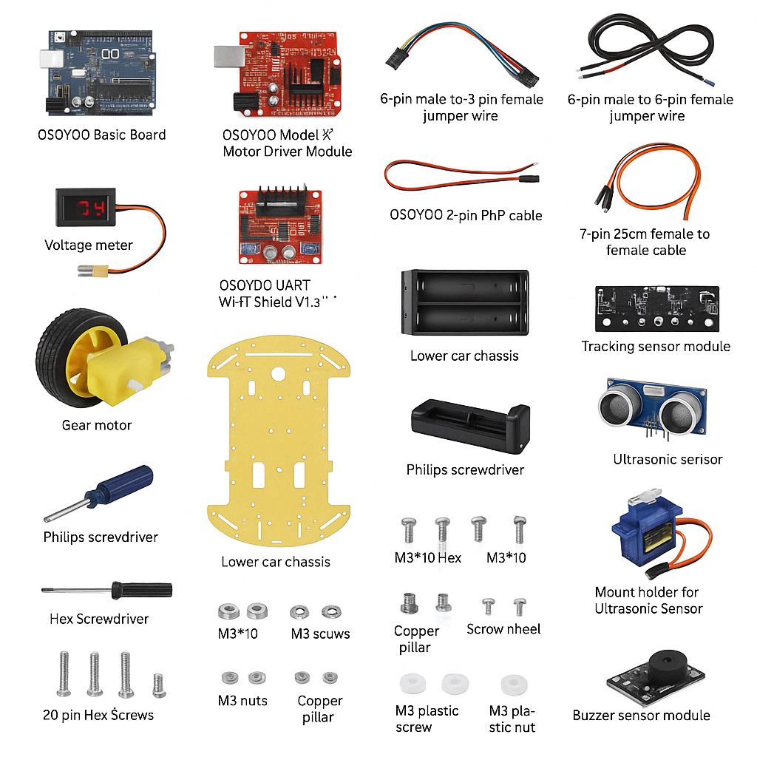

**Abstract**

This project presents the development, implementation, and testing of an autonomous Arduino-based robotic car designed to follow a black line on a white surface and avoid obstacles. The car's behavior was fine-tuned through a combination of hardware adjustments and robust software development. The system prioritizes obstacle avoidance over line tracking and includes mechanisms to intelligently rejoin the line after encountering an obstacle. Although the project faced multiple challenges, including hardware malfunctions and sensor limitations, successful navigation behaviors were achieved. Future improvements are proposed to enhance the system's navigation capabilities and reliability.

**Table of Contents**

1. Introduction
2. Objectives
3. System Overview
4. Hardware Components
5. Software Architecture
6. Implementation Details
7. Testing and Results
8. Discussion
9. Future Work
10. Conclusion

**1. Introduction**

The primary aim of this project was to develop an autonomous robotic vehicle capable of navigating a predefined environment by following a black line and avoiding obstacles. In robotics, line tracking and obstacle avoidance are fundamental skills required for real-world applications such as automated delivery systems and warehouse robots. The project involved strategic planning, system design, hardware assembly, software development, and rigorous testing to ensure operational success. Throughout the project, challenges such as sensor malfunctions, motor tuning, and behavior integration were encountered and addressed.

**2. Objectives**

The project objectives were as follows:

* Design a system that follows a black tape line reliably.
* Implement an obstacle detection and avoidance mechanism.
* Prioritize obstacle avoidance over line tracking.
* Ensure the robot can rejoin the line after avoiding an obstacle.
* Develop modular, easy-to-debug code.
* Analyze hardware and software performance during testing.

**3. System Overview**

The robotic system integrates hardware components such as motors, IR sensors, ultrasonic sensors, and a servo motor, controlled via an Arduino-compatible OSOYOO basic board. Software algorithms handle sensor data processing, decision-making, and motor control to enable navigation.

**4. Hardware Components**

**4.1 OSOYOO Basic Board**

* Arduino-compatible microcontroller board for programming and processing.

**4.2 OSOYOO UART Wi-Fi Shield V1.3**

* Provides communication interfaces and power management.

**4.3 Model X Motor Driver Module**

* Drives four DC motors independently based on PWM signals.

**4.4 Gear Motors and Wheels**

* Four motors connected to wheels provide omnidirectional movement.

**4.5 Ultrasonic Sensor and Servo**

* Measures distance to obstacles and scans surroundings by rotating.

**4.6 Line Tracking Sensor Module**

* Five IR sensors detect the black line position.

**4.7 Voltage Meter**

* Ensures battery voltage remains within operational thresholds.

**4.8 Power Supply**

* Battery box with 18650 rechargeable batteries.

**5. Software Architecture**

The software system is modular, with distinct functions for motion control, sensor reading, and decision-making.

**Pseudocode Overview**

**Setup Phase:**

* Initialize motors, ultrasonic sensor, buzzer, and servo motor.
* Center servo motor.
* Start serial communication.

**Motor Functions:**

* go_Advance (), go_Left (), go_Right (), stop_Stop (), set_Motorspeed ().

**Line Tracking Logic:**

* Read IR sensor values.
* Determine direction based on black tape detection.
* If no tape is detected, attempt to find tape within 2 seconds.

**Obstacle Avoidance Logic:**

* Measure distance via ultrasonic sensor.
* If an obstacle is detected:
  + Stop and wait.
  + Scan left and right.
  + Choose a direction with greater clearance.
  + Move and attempt to rejoin the line.

**Main Loop:**

* Execute line tracking and obstacle avoidance every 300 ms.

**6. Implementation Details**

Design decisions were made to prioritize obstacle avoidance. When an obstacle is detected, the car stops, evaluates alternative paths using the servo-mounted ultrasonic sensor, and decides on the better path forward. Only after clearing the obstacle does the car attempt to rejoin the black line.

An emergency stop after 3 seconds of white surface traversal was implemented to prevent the robot from falling off the edge.

Motor speeds were dynamically adjusted for smooth turns and stability. Modular functions allow quick debugging during testing phases.

**7. Testing and Results**

**7.1 Individual Feature Testing:**

* **Line Tracking:**
  + Fine-tuned sensor sensitivity.
  + Successfully followed the black line under optimal conditions.
* **Obstacle Avoidance:**
  + Challenges with distance accuracy.
  + Issues detecting bright-colored objects.
  + Darker obstacles were detected more reliably.

**7.2 Integration Testing:**

* Combined features into one program.
* Initial failures due to wiring issues and incorrect motor speeds.
* After troubleshooting, both line following and obstacle avoidance worked.

**7.3 Observations:**

* Successful obstacle avoidance and rerouting.
* Partial success in rejoining the line after an obstacle.
* Persistent malfunction in IR sensors affecting full functionality.

**8. Discussion**

Despite the challenges, the robot successfully demonstrated core behaviors. Hardware limitations, especially unreliable IR sensors, were significant barriers to achieving full line rejoining behavior. Diagnostic tests revealed that IR sensors falsely detected signals even on white surfaces, which impeded rejoining logic.

Lessons learned included the importance of robust hardware selection, modular coding practices, and systematic troubleshooting.

**9. Future Work**

Proposed improvements include:

* Adding rear ultrasonic sensors for backward obstacle detection.
* Installing additional low-height detection sensors.
* Upgrading to high-quality IR sensors.
* Integrating a small onboard camera to locate and rejoin the line using image processing.
* Developing a machine learning model for adaptive obstacle avoidance.

**10. Conclusion**

The project achieved its primary objectives, with a successful implementation of autonomous line following and obstacle avoidance. Though hardware constraints prevented full realization of line reacquisition, the project demonstrated strong foundational knowledge in robotics. Future iterations incorporating better sensors and vision technologies could significantly enhance performance.